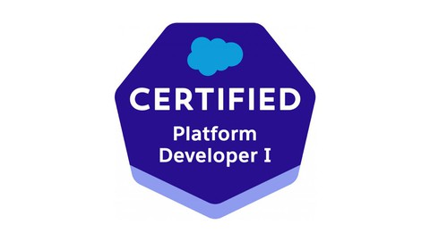

**Gopal Kshirsagar**

Pune| [gopalkshirsagarcloud@gmail.com](mailto:gopalkshirsagarcloud@gmail.com) |+91-9028497351|[linkedin.com/in/gopalkshirsagar](https://www.linkedin.com/in/gopalkshirsagar)

Salesforce Certified professional with total 4+ years of IT experience. To facilitate the organization in its growth and development, with focus on its goals and objectives, by putting sincere and dedicated hard work in harmony with others. My excellent analytical and problem-solving skills combined with a positive attitude make me a great team player.

* Salesforce Certified Platform Developer 1 (PD1).
* Experience in Data Exporting and Importing using Apex Data Loader.
* Having experience on Salesforce Lightning web Components.
* Having experience and good knowledge of Standard/Custom Objects, Junction objects, Fields, Validation Rules, Page Layouts and Tabs.
* Having experience of Flow, Process Builder, Workflows Rules, Roles &Profiles.
* Having work experience on Security Settings, Sharing Rules, OWD, Public Groups.

**SKILLS**

**_________________________________________________________________________**

Salesforce CRM , Force.com , DML , SFDC , Data Loader , Process Builder , Process Builder , LWC , SOQL , JIRA , Agile , Salesforce Admin , Apex Trigger, Apex Class , Asynchronous Apex, Flow

**EXPERIENCE**

**_________________________________________________________________________**

IT-NetworkZ Infosystem Pvt Ltd Nagpur, India

May 2019 - Present

**PROJECT EXPERIENCE**

**_________________________________________________________________________**

Project : DAMAC PROPERTIES

DAMAC Properties based in Dubai operates internationally providing residential , commercial and leisure properties and has presence in the UAE, Saudi Arabia ,Qatar, Jordan, Lebanon, Oman, and the United Kingdom**.**

Responsibilities:

* Created Custom object, Fields ,Tabs , triggers, and workflows for the application.
* Maintained code for Apex Classes, Triggers, LWC and Controllers for smooth Business Requirements.
* Imported data by mapping to business objects in CRM system using Data Loader and Import/Export wizard.
* Worked on Validation rules, Workflow Rules, Page layouts to suit to the needs of the application.

Project : BESPIN GLOBAL

Bespin Global helps businesses accelerate cloud adoption with industry-leading solutions and consulting expertise, delivering service- level-driven outcomes.

Responsibilities:

* Developed Apex Classes & Triggers to implement the business logic as per the requirements.
* Worked as enhancement team member and performed the roles ofSalesforce.com Developer and Administrator in the organization.
* Developed and configured various Reports and Report Folders.
* Imported data using Data Loader .

**EDUCATION _________________________________________________________________________**

Bachelor of Engineering: Information Technology

Dr. Babasaheb Ambedkar College of Engineering ,Nagpur Aug 2009 - May2014